Battery Connection Board Specification

Table of Contents

1.0 INTRODUCTION 3
1.1 Purpose 3
1.2 Scope 3
1.3 Revision History 3
2.0 Glossary / Acronyms 3
3.0 OVERVIEW 3
4.0 Electrical Requirements 4
4.1 Specifications 4
4.2 Interconnects 4
4.2.1 Power Management Connector (J1) 4
4.2.2 Battery Connector 5
5.0 Mechanical Requirements 6
5.1 Size 6
5.2 Mounting 6
5.3 Cooling 6
5.4 Fabrication 6
5.5 Protection 6
5.6 Labeling 7
6.0 Packaging Requirements 7

INTRODUCTION

Purpose
The purpose of this document is to provide the requirements for the Battery Connection Board.

Scope
This document provides the requirements for the Battery Connection Board used in the PB 520, 540, 560, and 640.

Revision History
Revision | Date | Author | Change Description
A | 11/08/07 | T.Dubreuil | Initial release
B | 11/03/08 | G Sánchez | Clarify requirements, update to standard format.
C | 1/20/009 | G Sánchez | Incorporate updates from Verification Review

Glossary / Acronyms
Acronym | Definition
A | Ampere
PCBA | Printed Circuit Board Assembly
V | Volt

OVERVIEW
The Battery Connection Board provides the interconnections between the Power Management Board and the Battery. This PCBA is used in place of a cable or harness. PCBA mounted spring fingers provide a connection to the battery cell device and a connector on the PCBA provides the interface to the Power Management PCBA.

Electrical Requirements

Specifications
HWSBAB7 Traces used to provide battery power shall be capable of supporting 3A at 29.4V, reference section 4.2.2.

HWSBAB8 Traces used to provide battery power shall have less than 100mV drop at 3A, reference section 4.2.2.

HWSBAB9 The battery connection board shall provide an interconnect to allow measurement of the battery temperature, reference section 4.2.2.

HWSBAB10 The battery connection board shall provide an interconnect to allow reading of the battery memory device, reference section 4.2.2.

HWSBAB11 The battery connector shall support 1mm travel while providing a valid electrical contact between the battery and the Battery Connection Board.

HWSBAB12 Spring contacts shall be rated for 2X the maximum required current.

Interconnects

Power Management Connector (J1)
PIN NUMBER | SIGNAL NAME |  | PIN NUMBER | SIGNAL NAME
1 | -  (Battery -) |  | 2 | -  (Battery -))
3 | -  (Battery -) |  | 4 | -  (Battery -)
5 | TEMP |  | 6 | MEM
7 | +  (Battery +) |  | 8 | +  (Battery +)
9 | +  (Battery +) |  | 10 | +  (Battery +)

Battery Connector
Connector  Designation | PIN NUMBER | SIGNAL NAME |  | PIN NUMBER | SIGNAL NAME
J3 | 1 | +  (Battery +) |  | 2 | +  (Battery +)
J4 | 1 | MEM  (EEPROM) |  | 2 | MEM  (EEPROM)
J5 | 1 | TEMP  (EEPROM) |  | 2 | TEMP  (EEPROM)
J6 | 1 | -  (Battery -) |  | 2 | -  (Battery -)

Mechanical Requirements

Size
HWSBAB13 The length (L1) of the PCBA shall be 68mm +/- 1mm
HWSBAB14 The length (L2) of the PCBA shall be 43mm +/- 1mm
HWSBAB15 The width (W) of the PCBA shall be 45mm +/- 1mm
HWSBAB16 The thickness (T) of the PCBA shall be 1.60mm +/- 0.5mm

L2
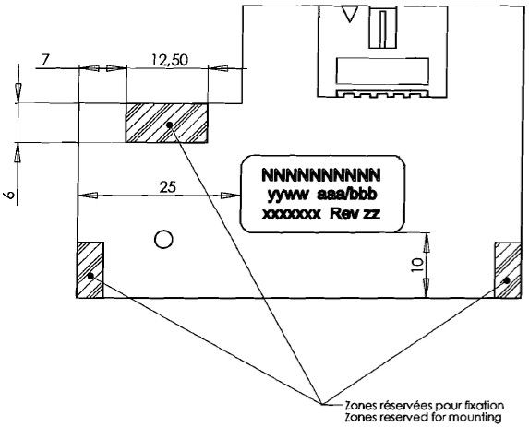
L1
W
Keep Out
4mm
8.5 mm

Mounting
HWSBAB17 Three areas shall be kept clear of traces and feed throughs on the J1 side of the PCBA to allow for mounting. The first area on the top (labeled Keep out) shall have a height of 6mm +/- 1mm and length of 12.5mm +/-1mm. The second area (labelled Keep Out) shall have a length of 4mm +/- 1mm and a height of 8.5mm +/- 1mm.

Cooling
N/A.

Fabrication
HWSBAB18 The Printed Circuit Board shall be fabricated per standard
IPC-A-610D: 2005, Acceptability for Electronic Assemblies – Class III

Protection
N/A.

Labeling
HWSBAB19 The PCBA shall be labeled with its Name, Part Number and Revision which is also human readable.

Packaging Requirements
HWSBAB20 Packaging shall be tested to the international standard ISTA2A.
HWSBAB21 Packaging shall be designed to minimize the level of waste and waste disposal as per the European Directive on handling waste packaging.

